機器學習 HW2

張之耀 P76061182

1. Extract features to describe the hand gesture and apply SVM to classify the “CSL” dataset.

CSL dataset裡面有26種手勢，分別對應A~Z。

我有寫一個create_label_file.py，會產生兩個txt檔，分別是test.txt跟train.txt，這兩個txt檔分別對應CSL資料夾內的train data跟test data，格式如下：

a001.jpg 0

a002.jpg 0

b001.jpg 1

b002.jpg 1

c001.jpg 2

c002.jpg 2

.

.

z001.jpg 25

z002.jpg 25

接著再執行hog_svm.py

執行環境：python 3.6 , scikit-learn 0.19.1(for SVC) , scikit-image 0.13.1(for HOG)

Comparision：

HOG feature block normalization, different SVM kernel and parameter.

(a). HOG feature block norm = L1：

Extract feature time : 11 sec

|  |  |  |
| --- | --- | --- |
|  | Kernel = “linear” | Kernel = “rbf” |
| C = 1.0 | Recall = 0.998 , Precision = 0.997 | Recall = 0.327 , Precision = 0.311 |
| C = 0.1 | Recall = 0.993 , Precision = 0.991 | Recall = 0.001 , Precision = 0.042 |
| C = 10.0 | Recall = 0.998 , Precision = 0.997 | Recall = 0.991 , Precision = 0.988 |

(b). HOG feature block norm = L1-sqrt：

Extract feature time : 11 sec

|  |  |  |
| --- | --- | --- |
|  | Kernel = “linear” | Kernel = “rbf” |
| C = 1.0 | Recall = 0.999 , Precision = 0.999 | Recall = 0.989 , Precision = 0.985 |
| C = 0.1 | Recall = 0.999 , Precision = 0.999 | Recall = 0.540 , Precision = 0.569 |
| C = 10.0 | Recall = 0.999 , Precision = 0.999 | Recall = 0.999 , Precision = 0.999 |

(c). HOG feature block norm = L2：

Extract feature time : 11 sec

|  |  |  |
| --- | --- | --- |
|  | Kernel = “linear” | Kernel = “rbf” |
| C = 1.0 | Recall = 0.998 , Precision = 0.997 | Recall = 0.992 , Precision = 0.990 |
| C = 0.1 | Recall = 0.997 , Precision = 0.997 | Recall = 0.249 , Precision = 0.263 |
| C = 10.0 | Recall = 0.998 , Precision = 0.997 | Recall = 0.997 , Precision = 0.997 |

(d). HOG feature block norm = L2-Hys：

Extract feature time : 11 sec

|  |  |  |
| --- | --- | --- |
|  | Kernel = “linear” | Kernel = “rbf” |
| C = 1.0 | Recall = 1.000 , Precision = 1.000 | Recall = 0.999 , Precision = 0.999 |
| C = 0.1 | Recall = 1.000 , Precision = 1.000 | Recall = 0.999 , Precision = 0.999 |
| C = 10.0 | Recall = 1.000 , Precision = 1.000 | Recall = 0.999 , Precision = 0.999 |

Cross validatoin results (5-fold)：

I pick HOG feature with L2-Hys, and SVM kernel = “linear”, C = 1.0

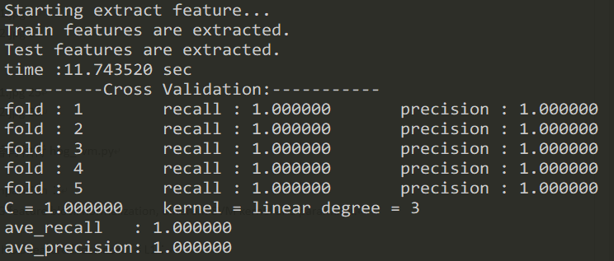

I pick HOG feature with L2-Hys, and SVM kernel = “rbf”, C = 1.0

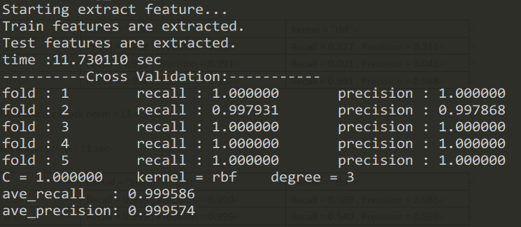

Result：

HOG feature with L2-Hys, and SVM kernel = “linear”, C = 1.0

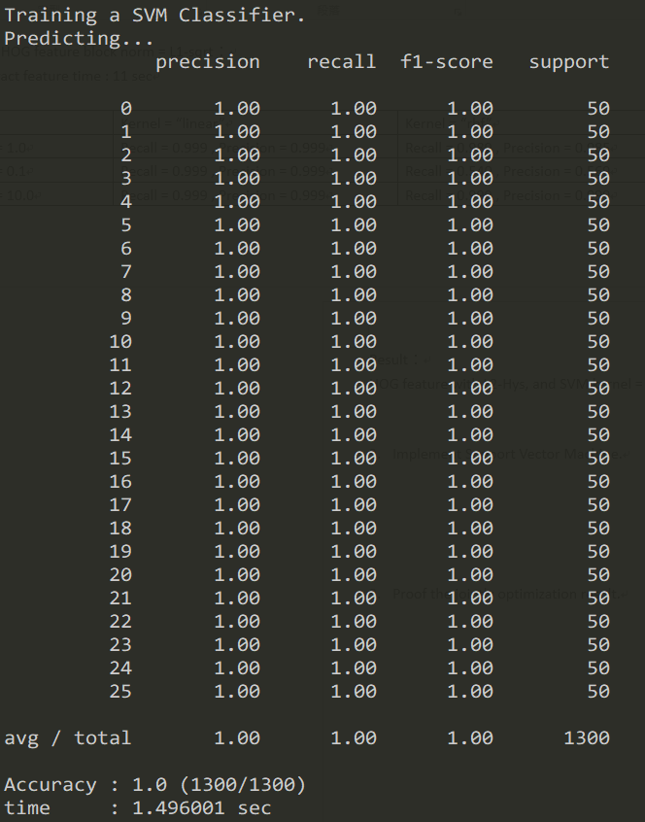

HOG feature with L2-Hys, and SVM kernel = “rbf”, C = 1.0

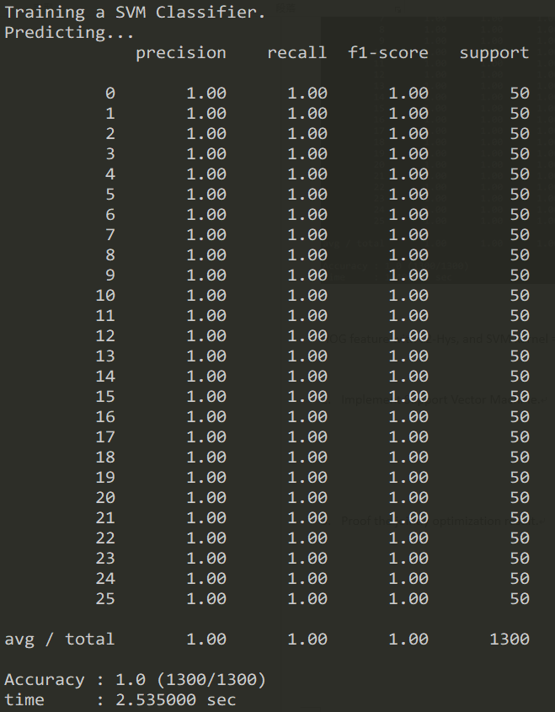

1. Implement Support Vector Machine.

執行環境：python 3.6

C = 1.0, sigma = 1

Using linear kernel :

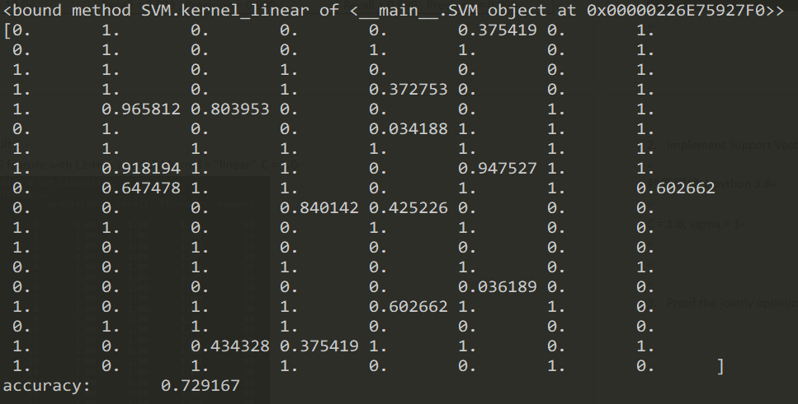

Using rbf kernel :

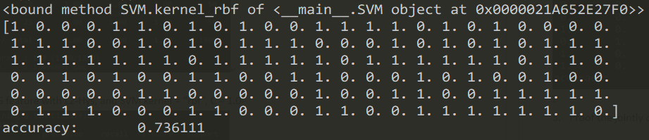

Algorithm；

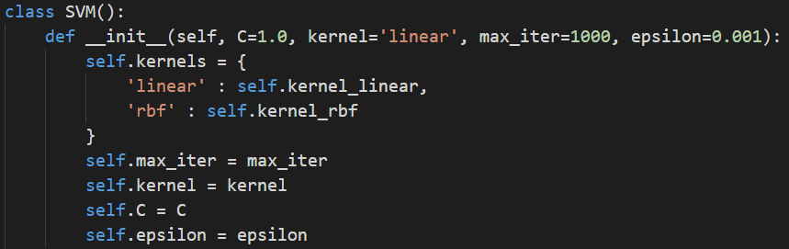

我把SVM包在class裡面，可以透過設定參數，調整裡面的值



class 裡面有一個fit的function，跟sklear裡面的SVC的fit一樣

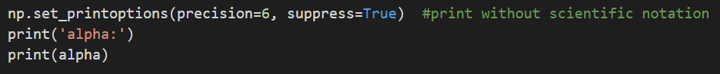

最後會把更新完的alpha印出來



如果要predict，就call這個function

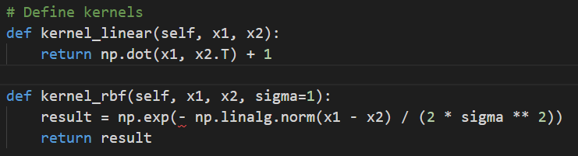

Linear跟rbf的kernel

1. Proof the jointly optimization result

